Volatility Estimator Analysis

Introduction

This mini-project provides an overview of how volatility is defined, measured, and interpreted in the context of financial assets. Volatility is a central concept in risk management and portfolio construction, as it captures the magnitude of price fluctuations and helps investors assess uncertainty in returns.

Motivation

When comparing funds or investment strategies, investors often face difficulty in determining which option offers the most attractive risk–reward trade-off. While many platforms provide volatility metrics for assets and mutual funds, these figures are frequently presented without sufficient context, making them hard to interpret or compare meaningfully. For this project, we have built a tool that computes and compare different volatility measures on the same asset. Start with simple historical volatility using log returns and then add rolling windows (20, 60, 120 days) and an EWMA version to capture recent shocks faster. Extend it by comparing realized volatility before and after macro events like CPI or CB meetings

Scope of Analysis

For our project, we will be analysing volatility through the use of Simple Rolling Windows, Exponential-Weighted Moving Averages, Realised Volatility, as well as standard deviation, correlation, alpha and beta when comparing our asset portfolio with a benchmark (SPY).

Period of analysis: Up to individual to decide
Dataset: Yahoo Financial data from 2005 to 2025 (Frequency of 1-Day)
Assets in focus (ticker symbols): AAPL, MSFT, GOOGL, AMZN, TSLA, BRK-B, JPM, JNJ, V
Benchmark: SPY

To analyse volatility in greater detail, the analysis is augmented with major macro-economic shocks and market events that occurred during the sample period. These events are used to contextualise spikes in volatility and assess how markets respond to periods of systemic stress. The macro-economic events considered are as follows:

Event | Start Date | End Date
Global Financial Crisis | 2008-09-15 | 2009-03-09
European Debt Crisis | 2010-04-23 | 2012-07-31
US Debt Ceiling Crisis & S&P Downgrade | 2011-07-25 | 2011-10-14
Chinese Stock Market Turbulence | 2015-06-12 | 2015-09-30
Brexit Referendum | 2016-06-23 | 2016-07-11
2018 Stock Market Sell-Off | 2018-01-26 | 2018-02-08
COVID-19 Pandemic | 2020-02-20 | 2020-03-23
Russia–Ukraine War | 2022-02-24 | 2022-03-08
US Regional Banking Crisis (SVB, Signature) | 2023-03-08 | 2023-03-17

Our Data at a glance

Pulling our data from YFinance and plotting the closing prices of our assets over time yielded the following chart.

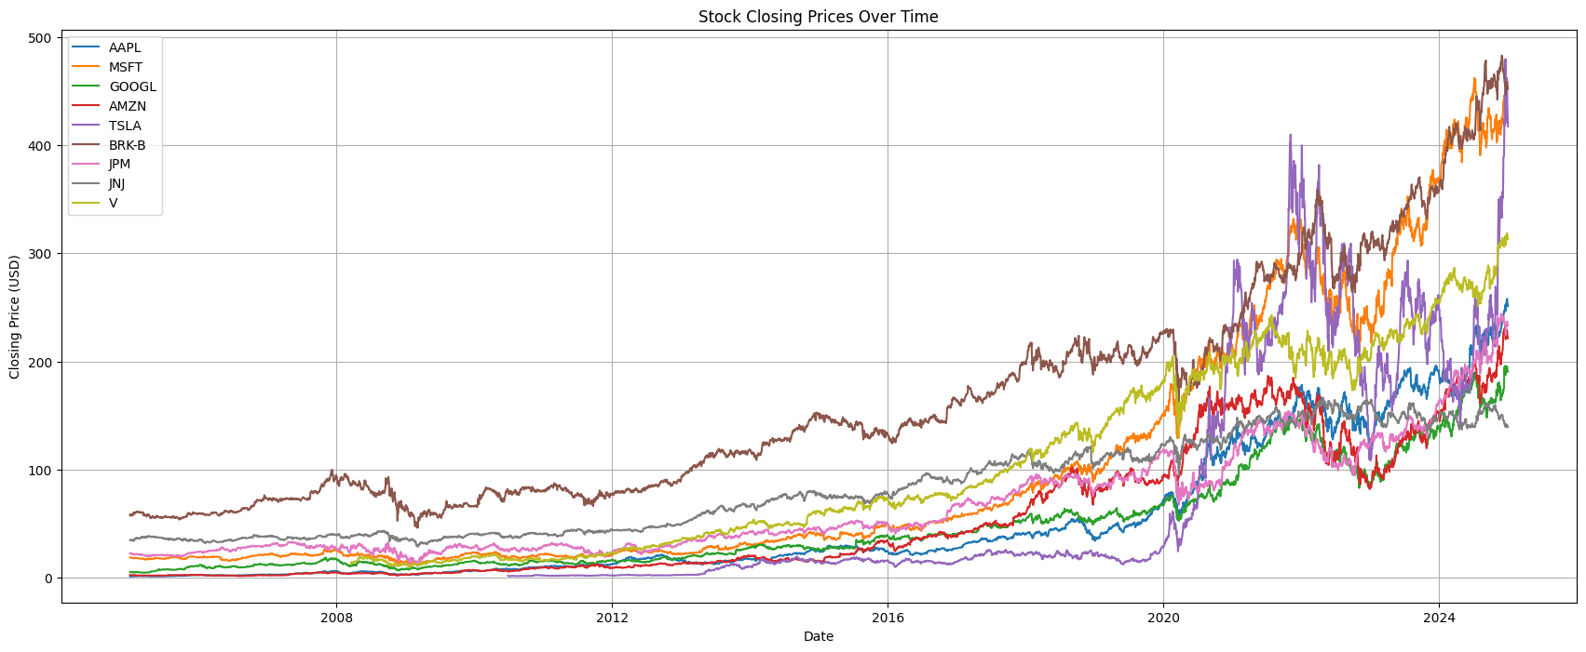

Analysing the volatility of one asset

If we take one asset (TSLA), and compute the relevant volatilities measure using the daily log-returns, we will get the following charts shown below.

